Task (05-11-2026)

https://www.geeksforgeeks.org/problems/second-largest3735/1
class Solution:
def getSecondLargest(self, arr):
# code here
maximum_element=-2**31
second_maximum_element=-2**31
second_maximum_element_not_found=-1
n=len(arr)

for i in range(0,n):
if arr[i]>maximum_element:
second_maximum_element=maximum_element
maximum_element=arr[i]

elif arr[i]!=maximum_element and arr[i]>second_maximum_element:
second_maximum_element=arr[i]

if second_maximum_element==-2**31:
return second_maximum_element_not_found
else:
return second_maximum_element

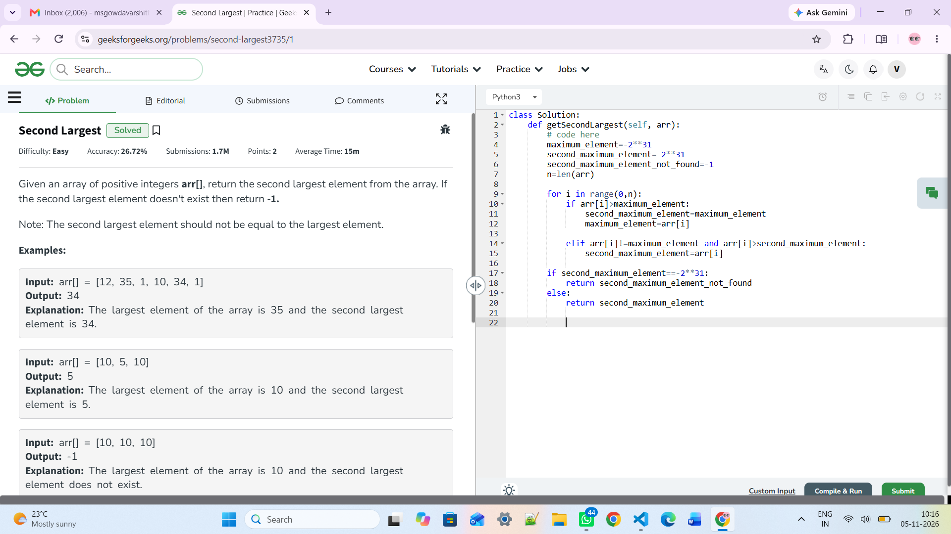

https://www.hackerearth.com/practice/data-structures/arrays/1-d/practice-problems/algorithm/print-array-in-reverse/

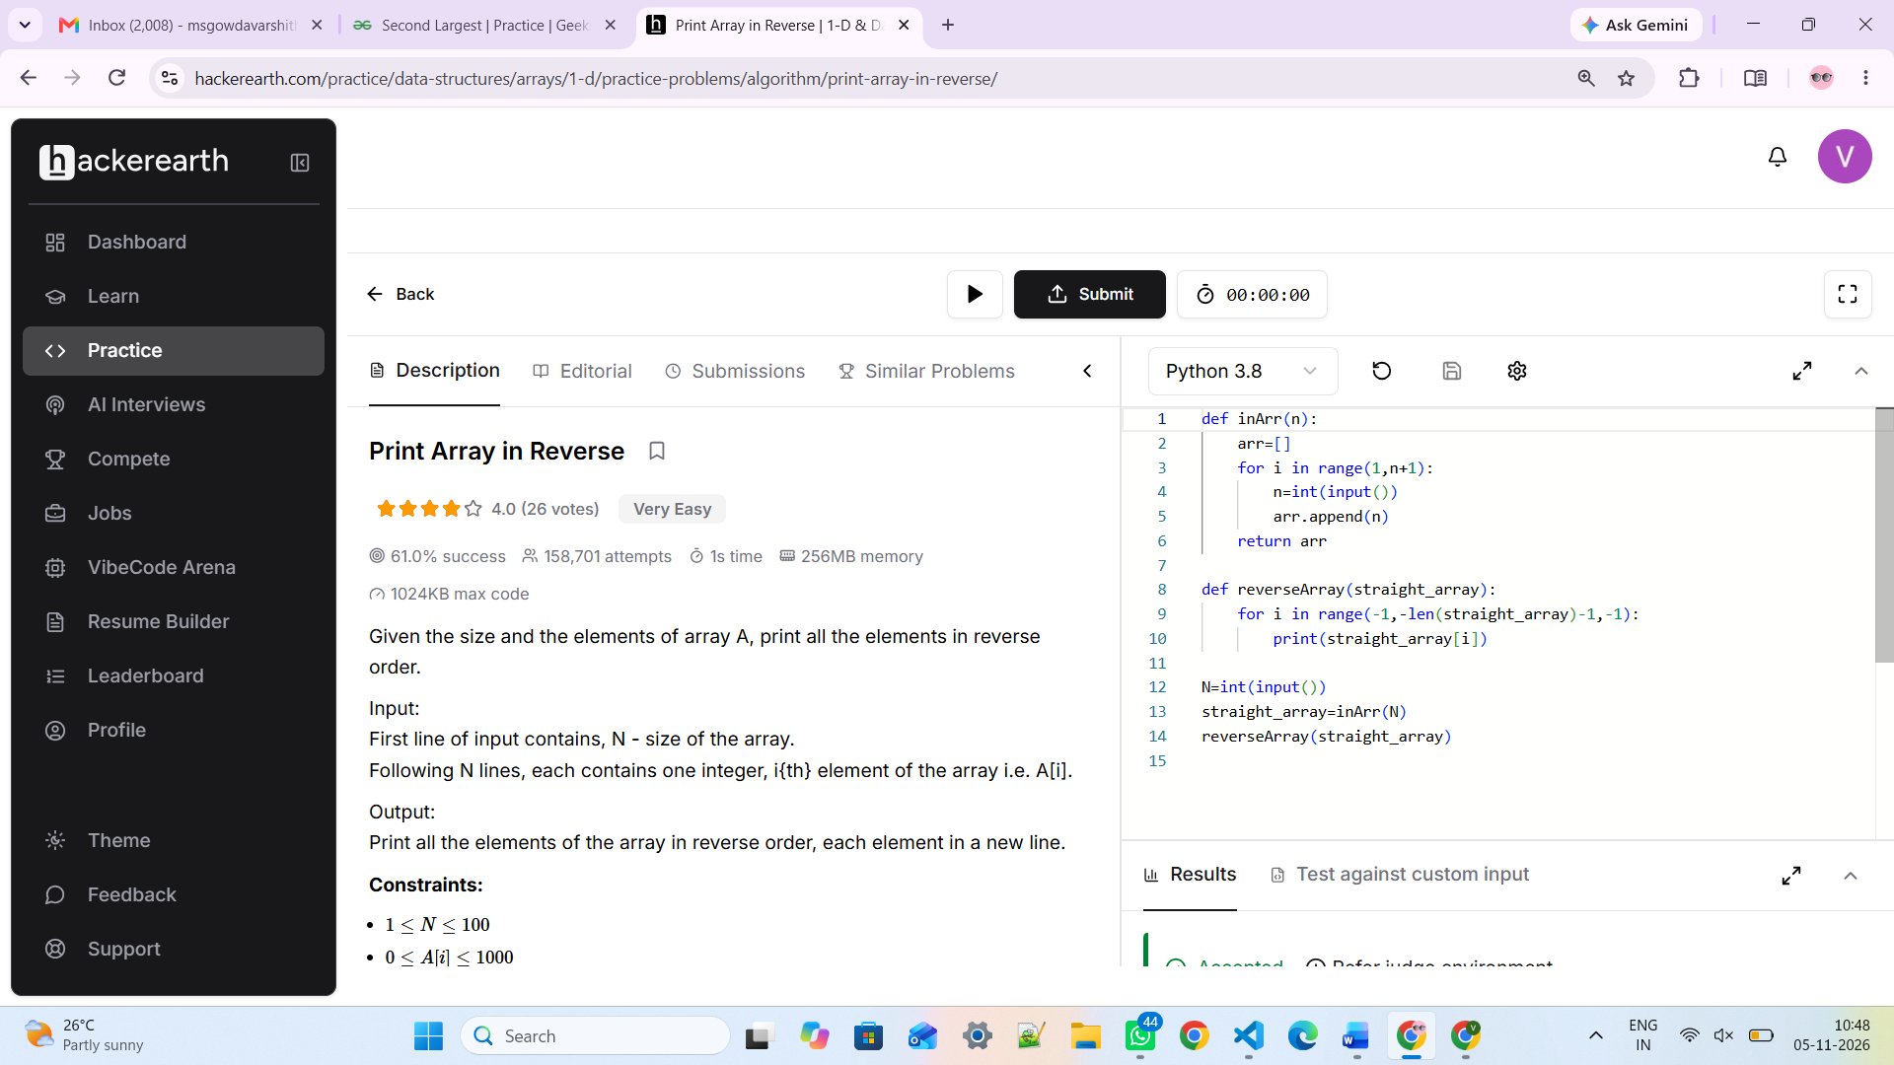

def inArr(n):
arr=[]
for i in range(1,n+1):
n=int(input())
arr.append(n)
return arr

def reverseArray(straight_array):
for i in range(-1,-len(straight_array)-1,-1):
print(straight_array[i])

N=int(input())
straight_array=inArr(N)
reverseArray(straight_array)

https://www.geeksforgeeks.org/problems/perfect-arrays4645/1

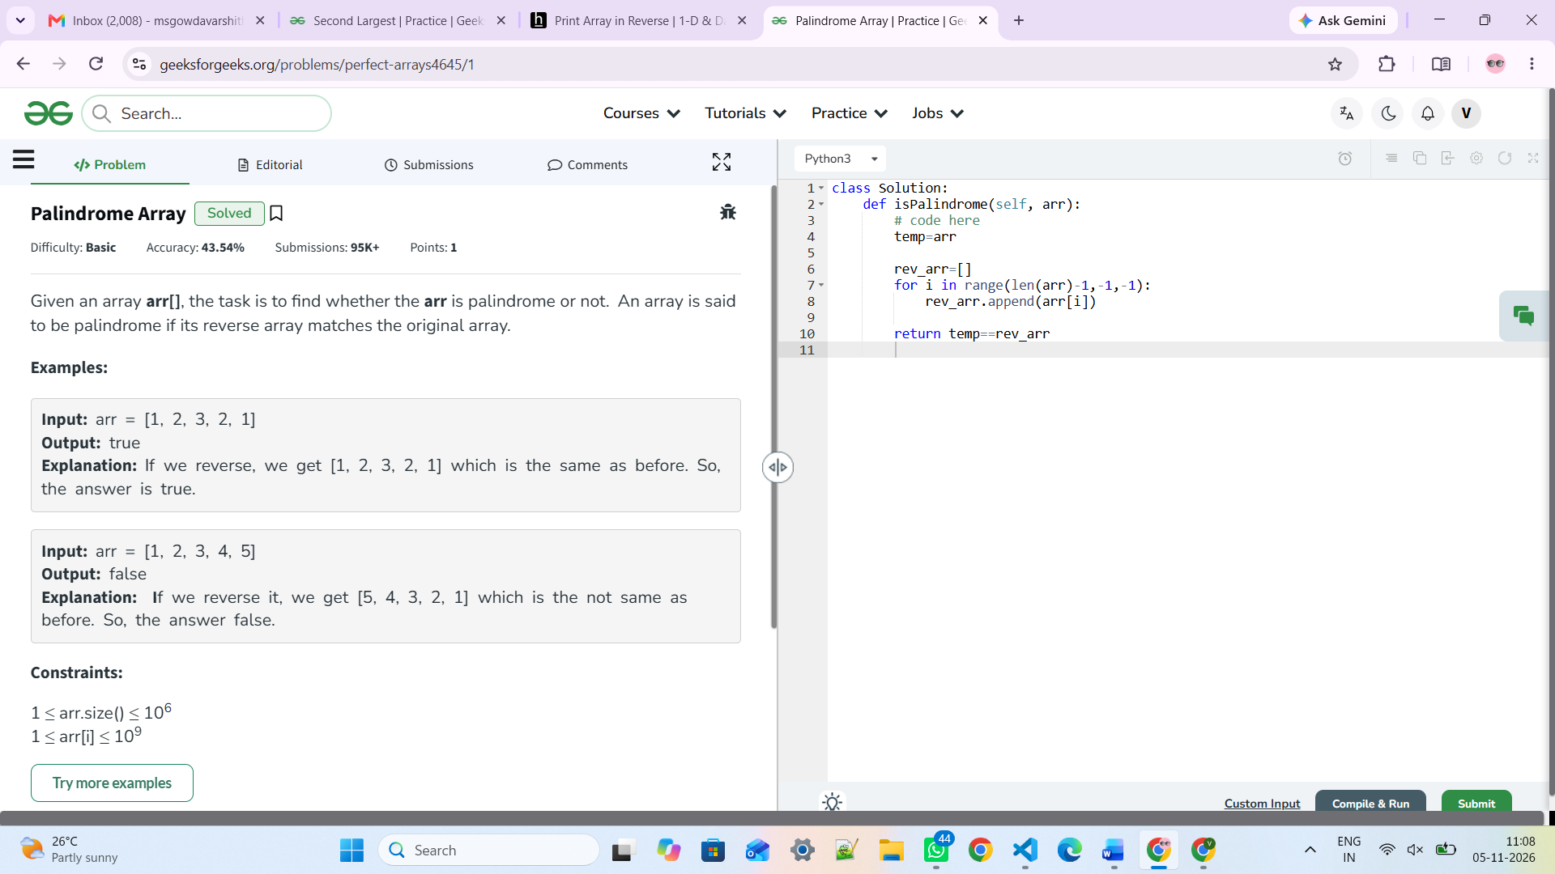
class Solution:
def isPalindrome(self, arr):
# code here
temp=arr

rev_arr=[]
for i in range(len(arr)-1,-1,-1):
rev_arr.append(arr[i])

return temp==rev_arr

https://www.geeksforgeeks.org/problems/search-an-element-in-an-array-1587115621/1

class Solution:
def search(self, arr, x):
# code here
element_found_index=-1

for i in range(0,len(arr)):
if arr[i]==x:
element_found_index=i
break

return element_found_index

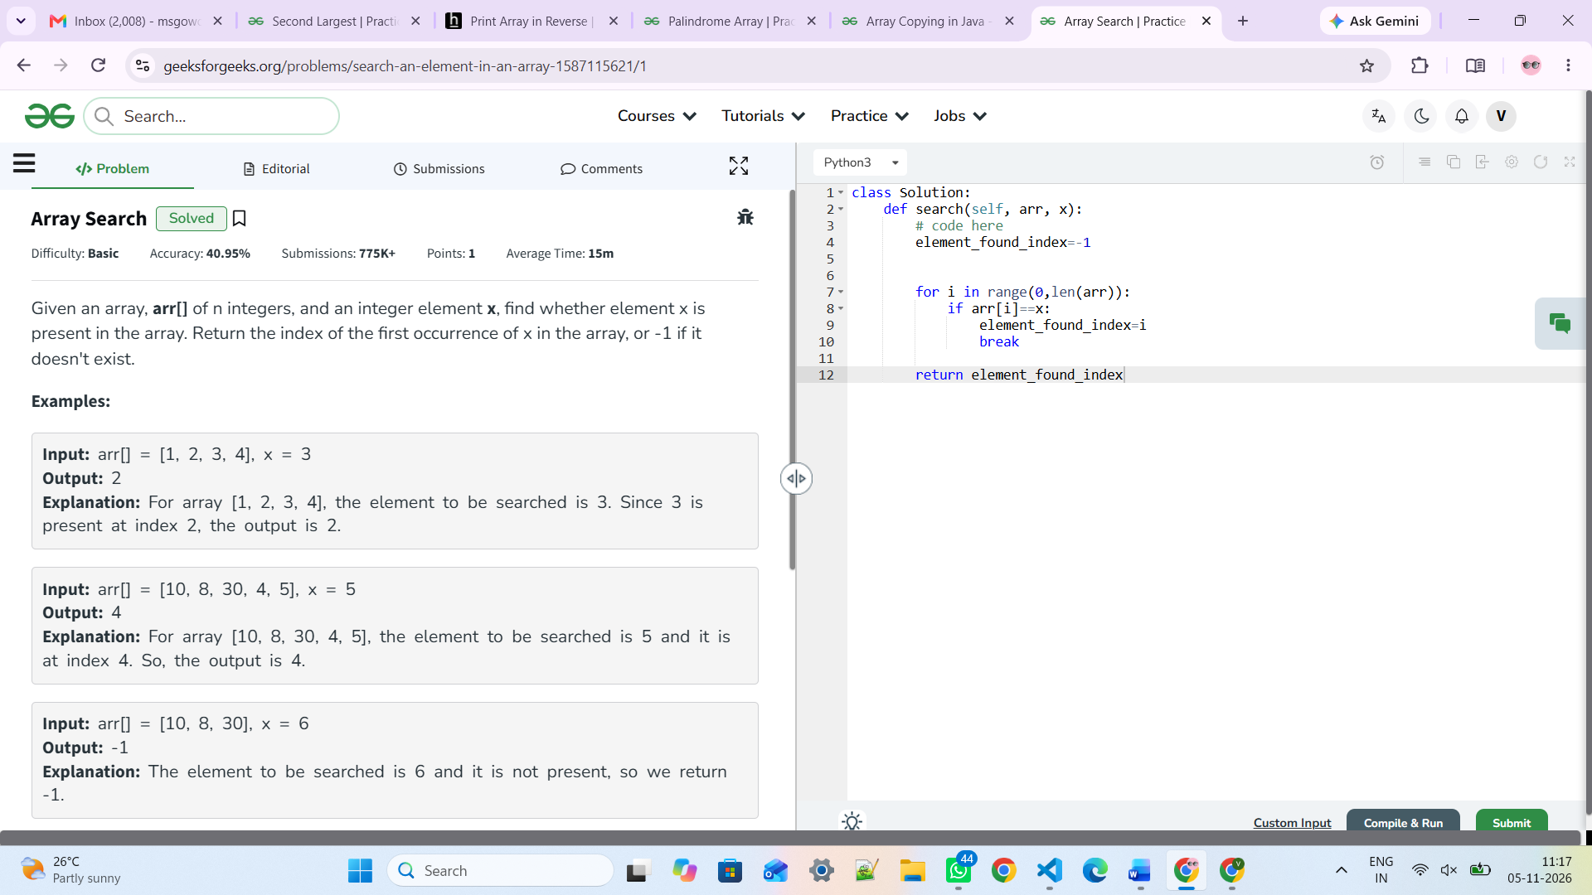

https://leetcode.com/problems/missing-number/description/

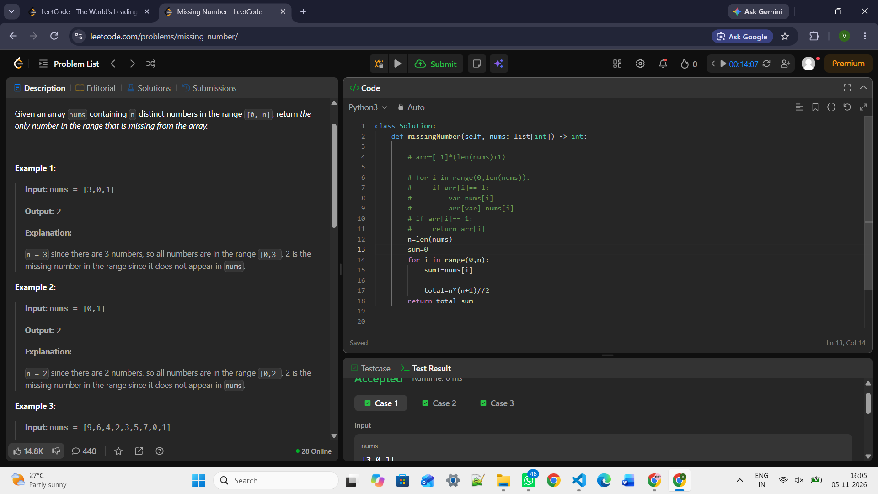
class Solution:
def missingNumber(self, nums: list[int]) -> int:

# arr=[-1]*(len(nums)+1)

# for i in range(0,len(nums)):
# if arr[i]==-1:
# var=nums[i]
# arr[var]=nums[i]
# if arr[i]==-1:
# return arr[i]
n=len(nums)
sum=0
for i in range(0,n):
sum+=nums[i]

total=n*(n+1)//2
return total-sum

https://www.geeksforgeeks.org/problems/missing-number-in-array1416/1

class Solution:
def missingNum(self, arr):
n = len(arr) + 1

total = (n * (n + 1)) // 2
arr_sum = 0

for i in range(len(arr)):
arr_sum += arr[i]

return total - arr_sum

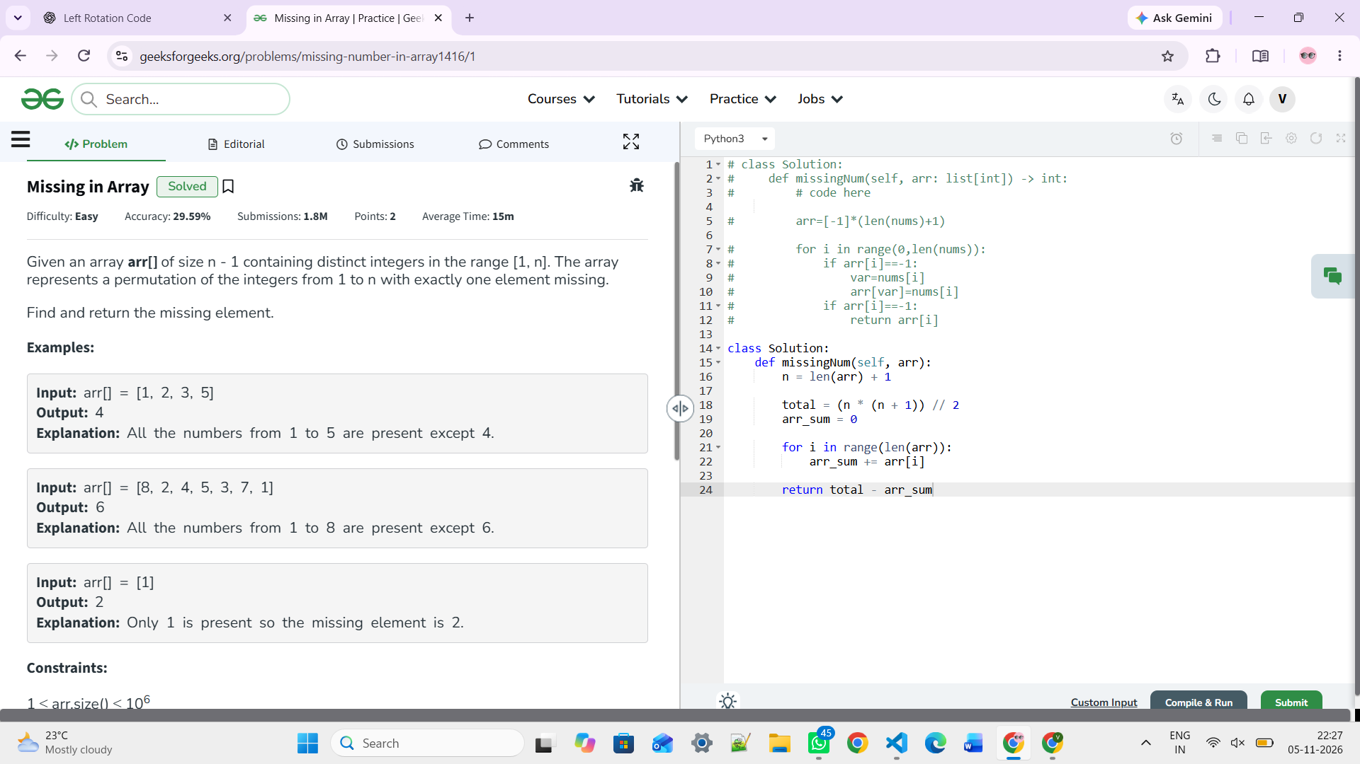

OR THIS LOGIC

class Solution:
def missingNum(self, arr):
n = len(arr) + 1

temp = [-1] * (n + 1)

for i in range(0, len(arr)):
var = arr[i]
temp[var] = arr[i]

for i in range(1, n + 1):
if temp[i] == -1:
return i

https://www.geeksforgeeks.org/problems/bubble-sort/1
class Solution:
def bubbleSort(self,arr):
# code here
n=len(arr)
for i in range(0,n-1):
for j in range(0,n-i-1):
if arr[j]>arr[j+1]:
arr[j],arr[j+1]=arr[j+1],arr[j]

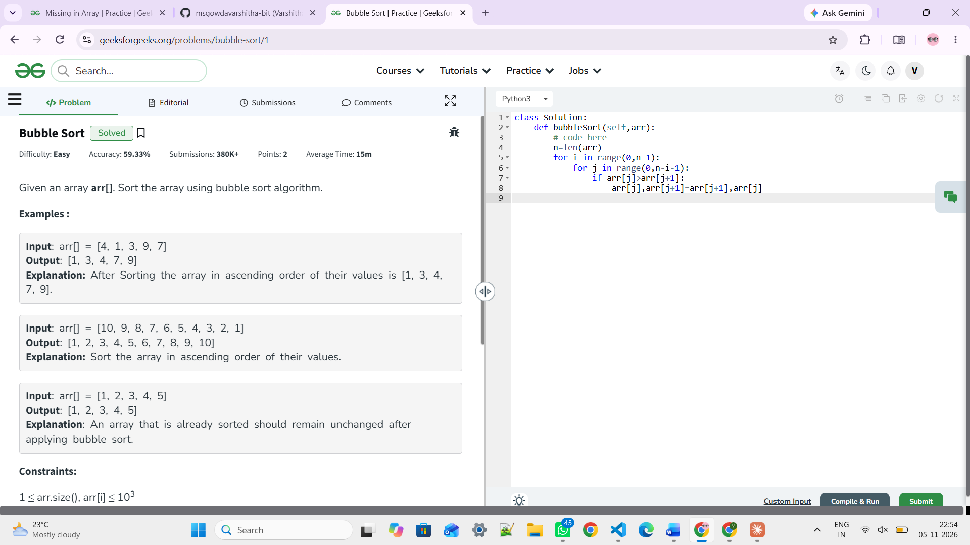

https://www.geeksforgeeks.org/problems/insertion-sort/1
class Solution:
def insertionSort(self, arr):
# code here
n=len(arr)

for i in range(0,n-1):
for j in range((i+1),1-1,-1):
if arr[j-1]>arr[j]:
arr[j-1],arr[j]=arr[j],arr[j-1]

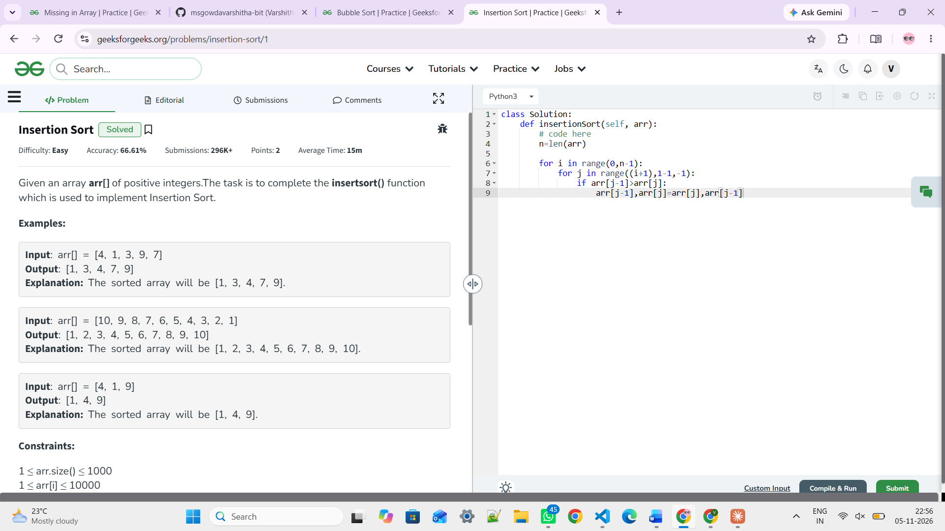

https://www.geeksforgeeks.org/problems/selection-sort/1

class Solution:
def selectionSort(self, arr):
# code here
n=len(arr)

for i in range(0,n-1):
maximum_element=2**31
maximum_element_index=-1
for j in range(i,n):
if arr[j]<maximum_element:
maximum_element=arr[j]
maximum_element_index=j

arr[i], arr[maximum_element_index] = arr[maximum_element_index], arr[i]
return arr

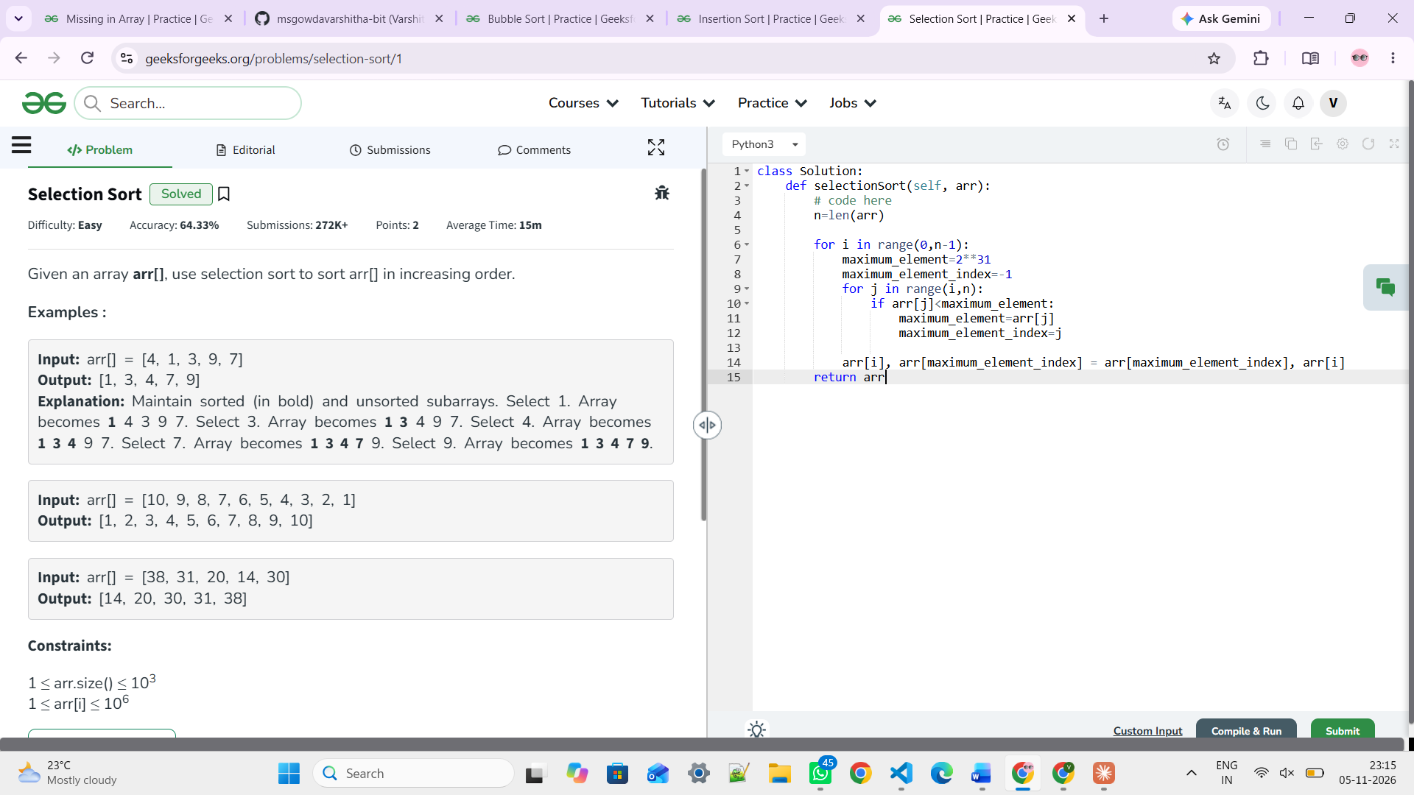

https://leetcode.com/problems/find-missing-elements/
class Solution:
def findMissingElements(self, nums: List[int]) -> List[int]:
low, high = min(nums), max(nums)
result = []
temp = [-1] * (high + 1)

for i in range(0, len(nums)):
var = nums[i]
temp[var] = nums[i]

for i in range(low, high + 1):
if temp[i] == -1:
result.append(i)

return result



